

Come out to the Annual Breakers Festival in Victoria.
BC Wheelchair Basketball and BC Breakers welcome
All BCWBS female members!
What: Fun Games & Skills Development for
BCWBS Female Members (with/without a physical disability)
Where: Spectrum High School, 957 Burnside Road, Victoria
When: Saturday, February 13, 2016 – 9:30am-4pm
Sunday, February 14, 2016 – 9:30am-3:30pm
Cost: - $30 without accommodation – registration deadline Feb 5
- $100 with 2-night accommodation with breakfast (double occupancy) – registration deadline Jan 20
*Participants must be a current BCWBS individual member to register
*The registration fee does not include meals
Registration: Please submit the registration form to BCWBS office by fax/email/mail by respective deadlines

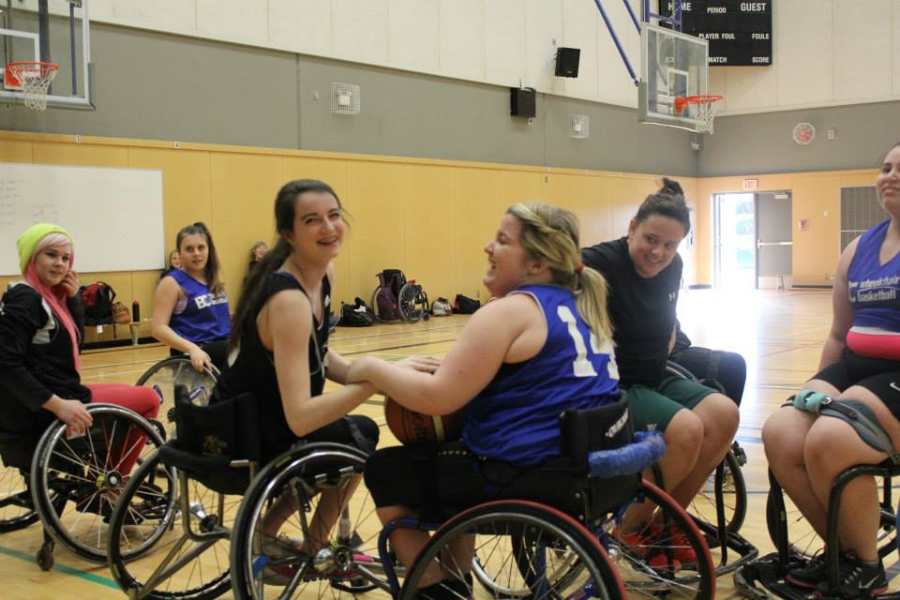
Open to all girls and women (able bodied or with a physical disability), we will have something for all levels of participants. A sport wheelchair can be provided upon request. The weekend will include wheelchair basketball games and skill development led by experienced BCWBS coaches. The Edmonton Inferno and Calgary Rollers women’s basketball teams will be in town playing games against the BC Breakers also, so it’d be a great chance to watch some fast paced games as well!
Please contact makiko@bcwbs.ca or call 604-333-3530 (ex: 3530) if you have any questions.

The event is also supported by:
BC Breakers Wheelchair Basketball Festival - Registration Form

I would like to register for:
- $30 without accommodation – registration deadline Feb 5
- $100 with 2-night accommodation with breakfast (double occupancy) – registration deadline Jan 20
*Registration fee does not include meals during the events.
I am:
- an individual member of BC Wheelchair Basketball for the 2015-16 season
- not a current individual member of BC Wheelchair Basketball:
  - I will include $35 (19 yrs+) or $20 (under 19) membership fee
  - My club will pay my membership fee [club name: ]
*Participants must be a current BCWBS individual member to register

*We accept Visa/MC or cheque. Please call 604-333-3530 or 3532 to pay by Visa/MC or mail a cheque (made out to BCWBS) to the BCWBS office.
*Please make a payment by Feb 5.
*Cancellation policy: No refund for a cancellation made after February 10.

Name: | Disability:  No  Yes - Please specify:
DOB (mm/dd/yy): | Need to borrow a sport wheelchair:  Yes  No
Address: |  |  | Postal:
Phone (H): (C): |  | Email:
Health Concern:

Consent and Waiver
I, on behalf of myself, members of my family, my heirs, executors, administrators and assigns, consent to and assume all risks and hazards of and incidental to my participation in the activities of the BC Wheelchair Basketball Society and forever release, discharge and hold harmless BC Wheelchair Basketball Society and all other parties, including agents, other associations and sponsoring companies, connected with BCWBS programs and events for any injury, loss or damage to my person or property howsoever caused, arising out of or in connection with my taking part in the BCWBS activities and notwithstanding that the same may have been contributed to or occasioned by the activities of BC Wheelchair Basketball Society and all other parties, including agents, servants and volunteers of BC Wheelchair Basketball Society, other associations and sponsoring companies. I also give full permission for use of my name and/or photograph/image in connection with BCWBS publications, website & other promotional materials.* We respect your privacy, and will not sell or share your personal information with any other party or organization without your consent

Athlete Signature Parent/Guardian Signature (if under 19) Date

Please submit the form/fee to:
Makiko Harada - BC Wheelchair Basketball Society (BCWBS)
780 SW Marine Dr. Vancouver BC V6P 5Y7
Tel: 604-333-3530 Fax: 604-326-1229 Email: makiko@bcwbs.ca



