2014 Wheelchair Basketball Have a Go
in Richmond
Registration Form
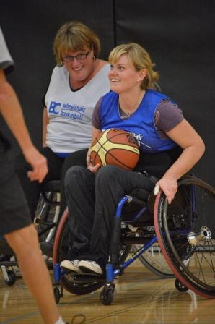
Whether you are new to the sport or have been playing for years, come out to the 2014 Richmond Wheelchair Basketball Have a Go to play! People with and without disabilities are welcome to attend, so bring your friends and come out for a fun filled evening!
*For a quality sport experience, the ability to follow a sequence of instruction, good upper body mobility and use of a manual wheelchair without assistance are required.

Tuesday, September 23, 2014
6:00pm-7:30pm
Steveston Community Centre
4111 Moncton Street Richmond
Fee: FREE, Age: 13+

Name* |  |  | *Male □ Female □
Address
City/Prov* |  | Postal*
Phone | Home - | Work -
 | Cell -
Email |  | Date of Birth*

Disability:

Will you need to borrow a BCWBS basketball wheelchair? Yes □ No □
The information provided on this form is collected and maintained by BC Wheelchair Basketball Society for the purposes for which it is intended and shall not be used for any other purpose or disclosed without the prior consent of members.

CONSENT AND WAIVER
I, the participant, on behalf of myself, members of my family, my heirs, executors, administrators and assigns, hereby forever release, discharge and hold harmless BC Wheelchair Basketball Society and all other associations and sponsoring companies and all other parties, including agents, other associations and sponsoring companies, connected with Wheelchair Basketball Have a Go, for any injury, loss or damage to my person or property howsoever caused, arising out of or in connection with my taking part in Wheelchair Basketball Have a Go and activities and notwithstanding that the same may have been contributed to or occasioned by the activities of BC Wheelchair Basketball Society and all other parties, including agents, servants and volunteers of the organizations, other associations and sponsoring companies. I also give full permission for use of my name, image and/or photograph in connection with this event.

Signature Parent/Guardian Signature Date
(if under the age of 19 yrs)


