2013 Wheelchair Basketball Have a Go
in Port Moody
Registration Form
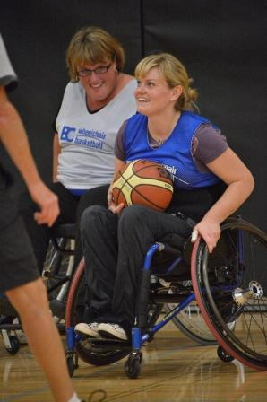
Whether you are new to the sport or have been playing for years, come out to the 2013 Port Moody Wheelchair Basketball Have a Go for fun games and skills sessions. Experienced players will have a chance to hone their skills and get additional game time and new players can try the sport in a fun, supportive environment. People with and without disabilities are welcome to attend, so bring your friends and come out for a fun filled evening!

Monday, September 9, 2013
5:00pm-7:30pm
Port Moody Recreation Complex
300 Ioco Road, Port Moody
Fee: FREE, Age: 13+

Name |  |  | Male □ Female □
Address
City/Prov |  | Postal
Phone | Home - | Work -
 | Cell -
Email |  | Date of Birth

Classification (if known):

Will you need to borrow a BCWBS basketball wheelchair? Yes □ No □
All information required. The information provided on this form is collected and maintained by BC Wheelchair Basketball Society, BC Wheelchair Sports Association, and The City of Port Moody for the purposes for which it is intended and shall not be used for any other purpose or disclosed without the prior consent of members.

CONSENT AND WAIVER
I, the participant, on behalf of myself, members of my family, my heirs, executors, administrators and assigns, hereby forever release, discharge and hold harmless BC Wheelchair Basketball Society, BC Wheelchair Sports Association, the City of Port Moody, and all other associations and sponsoring companies and all other parties, including agents, other associations and sponsoring companies, connected with Wheelchair Basketball Have a Go, for any injury, loss or damage to my person or property howsoever caused, arising out of or in connection with my taking part in Wheelchair Basketball Have a Go and activities and notwithstanding that the same may have been contributed to or occasioned by the activities of BC Wheelchair Basketball Society, BC Wheelchair Sports Association, the City of Port Moody and all other parties, including agents, servants and volunteers of the organizations, other associations and sponsoring companies. I also give full permission for use of my name, image and/or photograph in connection with this event.

Signature Parent/Guardian Signature Date

(if under the age of 19 yrs)





